Chapter 3

1. UNIFIED MODELING LANGUAGE

**UML** is a common language for business modeling, speculating, visualizing, building, documenting, and communication. This is a typical notation for representing actual items in the real world as the initial stage of creating an object-oriented design process. This is a strong notation that can convey information accumulated throughout the course of a project's lifecycle and may be used to model objects and data effectively.

A use case is depicted as a horizontal ellipse and depicts a series of behaviors that give an actor something of quantifiable value. The System Boundary identifies the System's domain. Any functionality that is covered by the research is represented by anything inside the box. An actor starts a use case to carry out a necessary task. A person, group, or external system that participates in one or more interactions with the system is referred to as an actor. An actor is often a human, however that isn't always the case. An actor can occasionally be a different computer system. For instance, when a roll-up report is needed for processing by an external system, that system could be viewed as an actor, and the creation of that roll-up report as a use case.

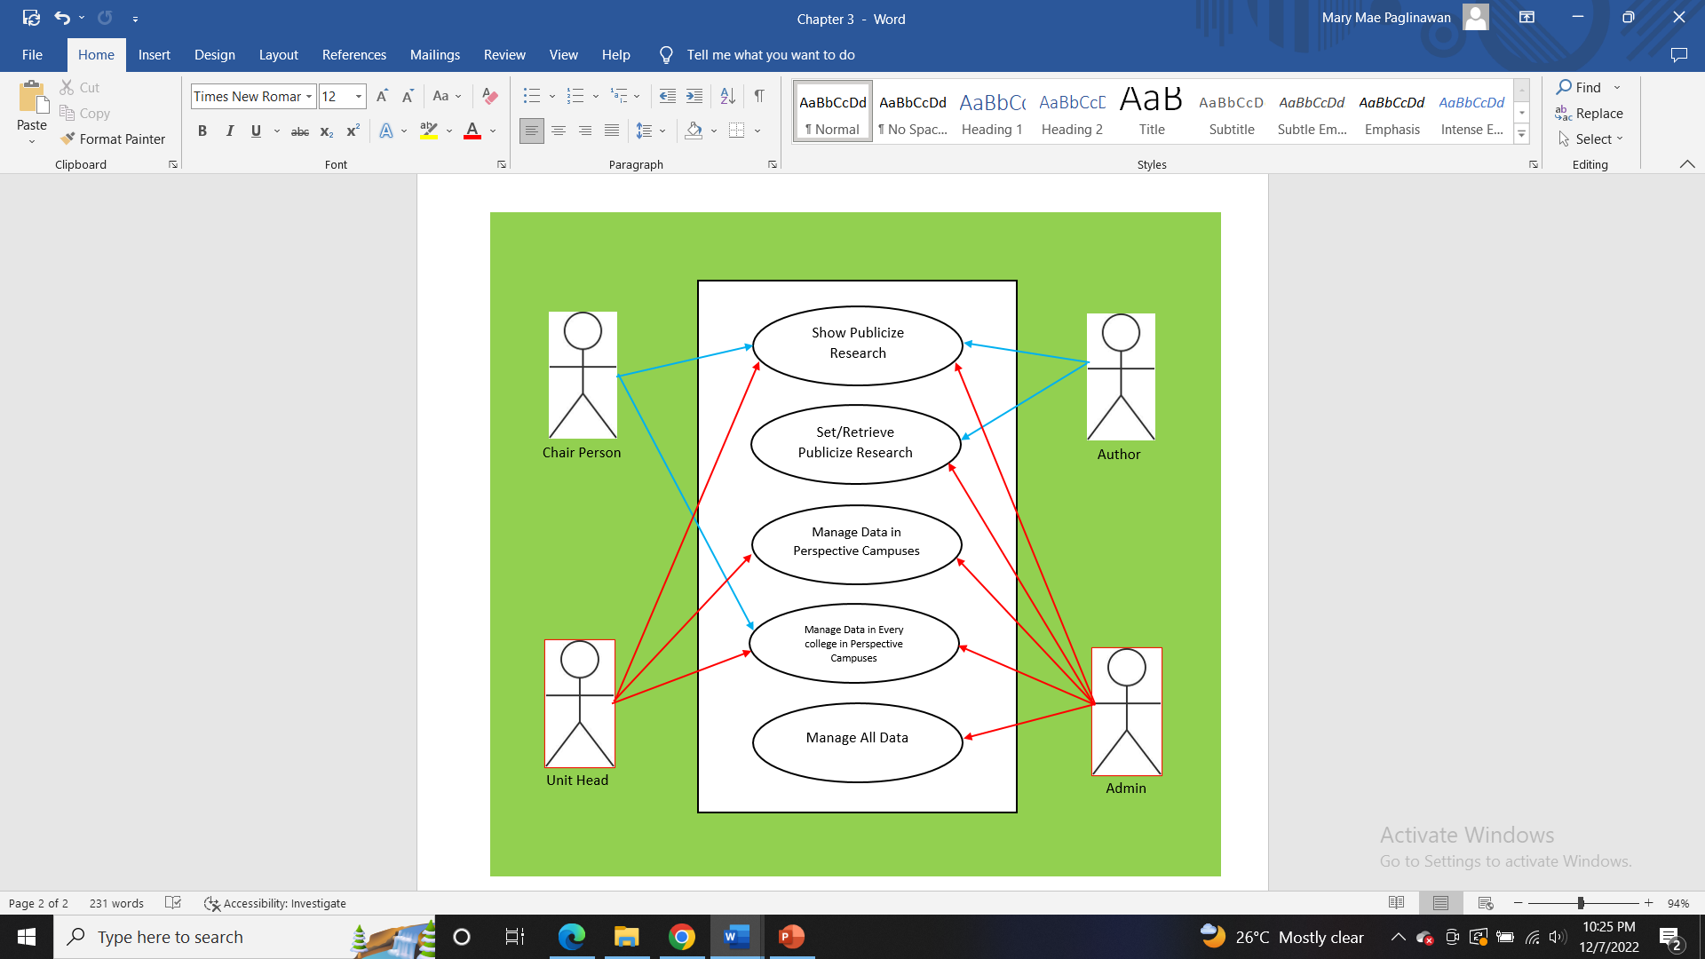

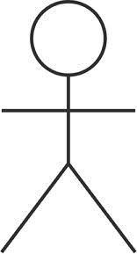

Author

Admin

Unit Head

Chair Person

UML - Class Diagram

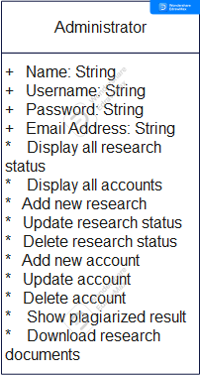

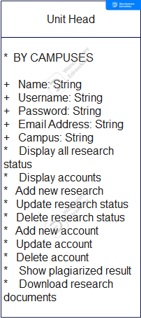

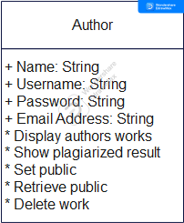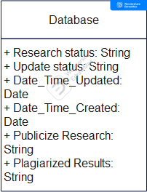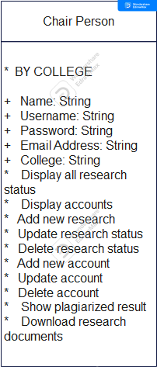

1. DATA FLOW DIAGRAM

The transfer of data between external entities, internal operations, and data repositories is depicted in a data flow diagram. System analysts (and system users) can visualize the data flow in an information system using this graphical tool. This is one of the techniques used by system analysts to gather data needed to ascertain the information system requirements: Student Information Main Database Administrator Scan Fingerprint () Confirm Information () Fines () Confirm Fines Types of Events Approved Total Fines () Reports () Update Database () Confirm Update ().

Context Diagram

a data flow diagram (DFD) illustrating the key information flows between the system's external users and the system's internal users, as well as the system's boundaries and other external users with whom it interacts.

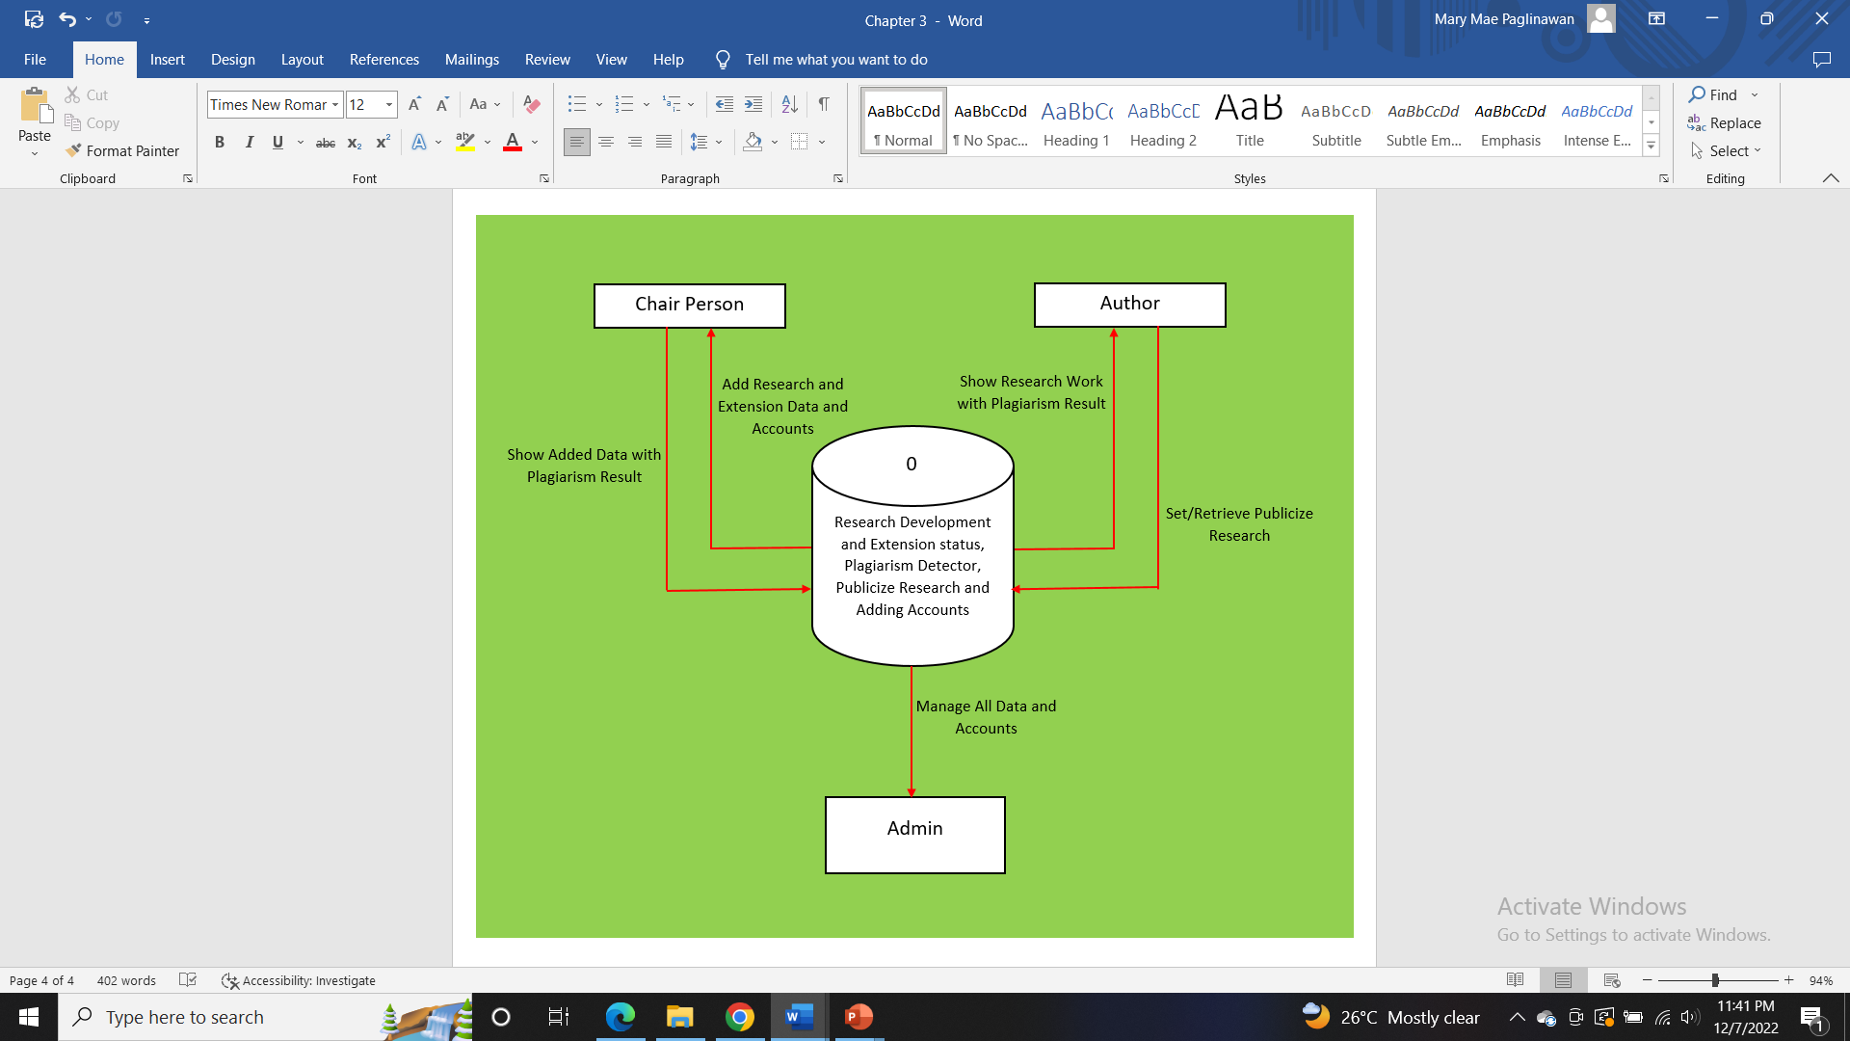

0

Manage All Data and Accounts

Set/Retrieve Publicize Research

Show Added Data with Plagiarism Result

Show Research Work with Plagiarism Result

Add Research and Extension Data and Accounts

Chair Person

Admin

Research Development and Extension status, Plagiarism Detector, Publicize Research and Adding Accounts

Author

Link/Site

Show Research Status with Plagiarism Result

Response

Register Result

Plagiarism Detector

Verify Information

Add Author Account

Add Research Status

Verify Information

Login

Verify Information

Response

Account Registered

Verify Information

Add Account

Database

Mobile

Server

1. **System Architectural Design**

Admin

Plagiarism Detector

**Failed** (no default requirement from admin)

Log Out

Successful

Set Research Status

Add Research Documents

Users Log-in

Register

**Failed** (the author can’t set the research status)